# Sewing Machine

# Item #1-A

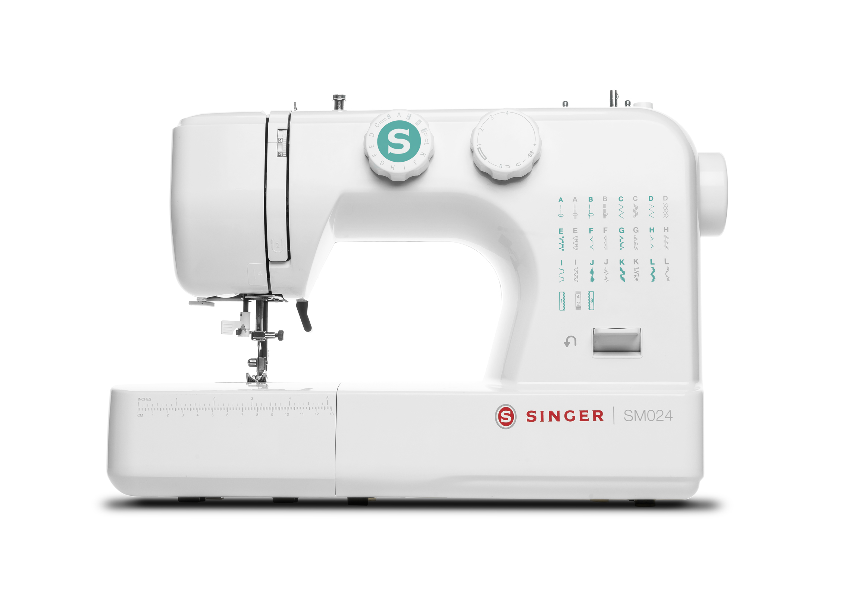

Item Description: The SINGER SM024 sewing machine featured with turquoise accents comes with 24 stitch options, front load bobbin system, a needle threader, and more making it simple to complete repairs or finish an entire project in a cinch. The SINGER SM024 sewing machine comes with 24 stitch options to make simple repairs and enhancements a cinch. Hobbyists will love its fast threading and reliable stitching —whether using the 4-step buttonhole feature or the all-purpose foot and free arm to create quality hems and cuffs. At any speed, a durable all-metal frame delivers the steady support expected in a SINGER sewing machine. And stitch by stitch, the needle feeder and easy-winding front-load bobbin are in full view beneath brilliant LED lighting.

Includes: Sewing Machine, Instruction Manual, power line cord, foot control, 3 bobbins, 3 needles, multi-function screwdriver, ripper/brush, buttonhole foot, Hem Guide for presser Foot, zipper foot, button sewing tool

Replacement Cost: $136

# Sewing Machine

# Item #1-B

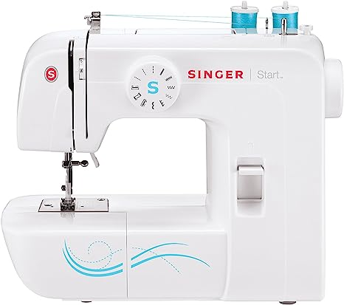

# Item Description: SINGER | Start 1304 Sewing Machine

The SINGER Start 1304 is the perfect sewing machine for beginners, sewists-on-the go, and simple sewing or mending projects.  The machine has 57 stitch applications, providing essential sewing techniques to get your projects finished faster. Whether you’re sewing a simple applique, fixing a hem, or adding decorative scallops to a garment, you will love having the SINGER Start 1304 by your side!

Includes: Sewing Machine, Instruction Manual, Power cord/foot pedal, all purpose foot, zipper foot,buttonhole foot, darning plate, L-screwdriver, seam ripper/brush, 2 spool pin felt, pack of 3 needles, bobbin

Replacement Cost: $120

# Telescope

# Item #2

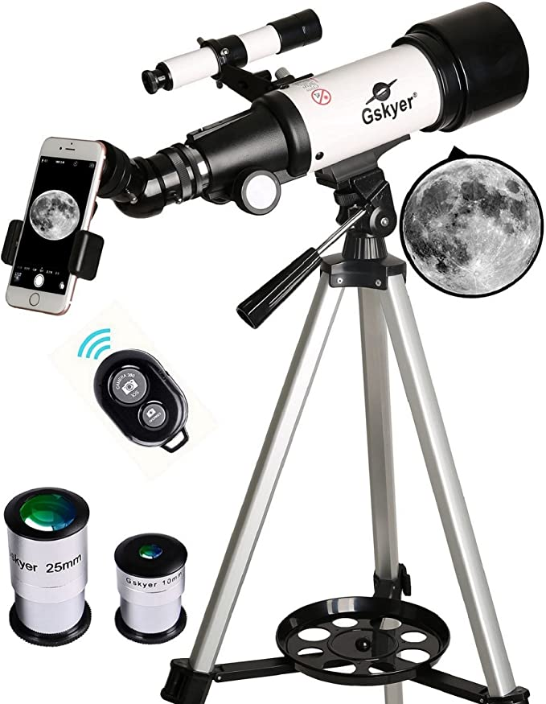

# Item Description: Gskyer Telescope, 70mm Aperture 400mm AZ Mount Astronomical Refracting Telescope

Quality Optics: 400mm(f/5.7) focal length and 70mm aperture, fully coated optics glass lens with high transmission coatings creates stunning images and protect your eyes. Perfect telescope for astronomers to explore stars and moon.

Includes: Telescope, adjustable tripod, carry bag, 2 replaceable eyepieces, 3X Barlow lens, smart phone adapter, wireless camera remote, Set Up guide

Replacement Cost: $90

# Volleyball and Badminton Combo Set

# Item #3

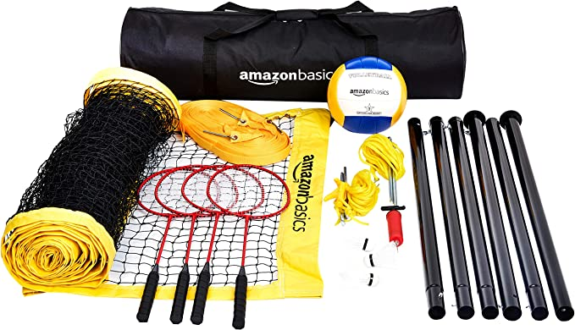

Item Description: Complete volleyball and badminton set for outdoor use.

Includes: Net, 6 poles, 2 tension ropes, boundary line, 4 racquets, 3 birdies, volleyball, pump, carrying case

Replacement Cost: $87

# Croquet Set

# Item #4

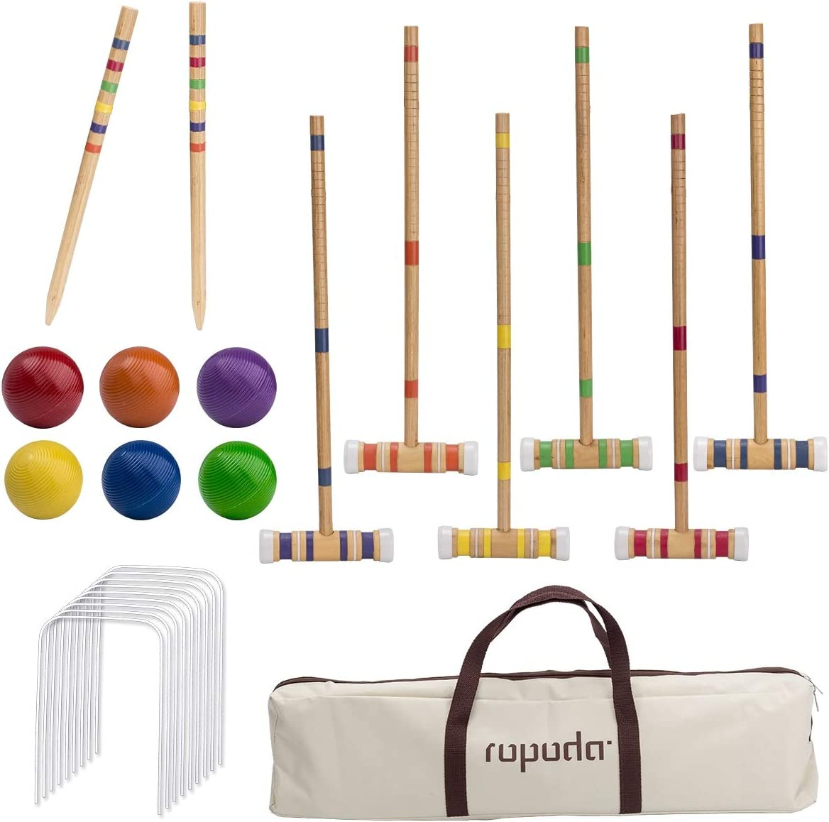

# Item Description: Ropoda Croquet Set for 2-6 players

# Includes: 6 wooden mallets, 6 colored balls, 2 ending stakes, 9 steel wickets and a carry bag.

Replacement Cost: $44

# Wheeled Cooler

# Item #5

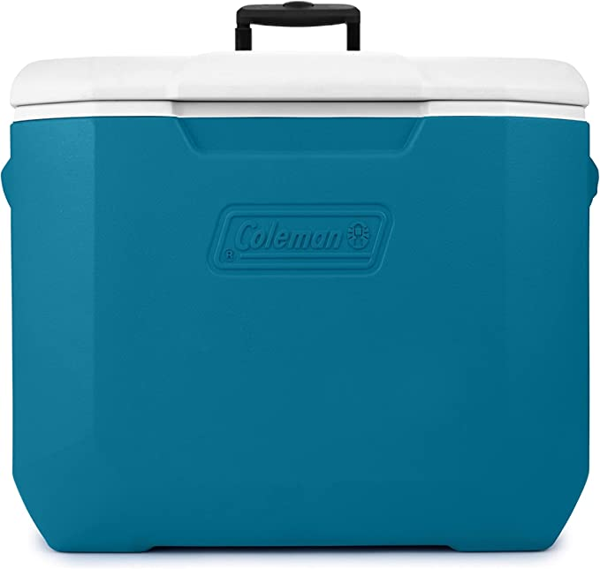

# Item Description: Wheeled Insulated Portable Cooler

* ICE RETENTION: TempLock insulation keeps drinks ice cold
* PORTABLE: Recessed wheels and a retractable handle with comfort grip make it easy to move

Replacement Cost: $50

# Metal Detector

# Item #6

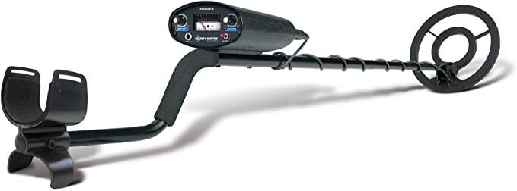

# Item Description: Bounty Hunter TK4 Tracker IV Metal Detector

* Rugged metal detector ideal for detecting treasure in extreme ground conditions
* Motion All-Metal mode, Discrimination mode, and 2-Tone audio mode
* Preset ground balance neutralizes response to mineral content in the ground
* Disc/notch control distinguishes between targets and unwanted metals

# Includes: Metal Detector, manual

Replacement Cost: $120

# Karaoke Machine

# Item #7

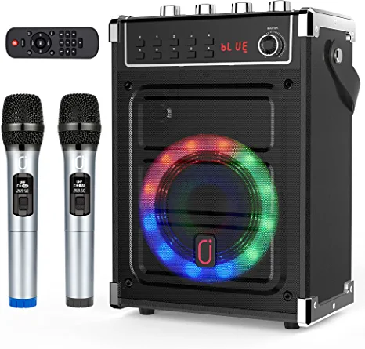

# Item Description: JYX Karaoke Machine

# Includes: 2 UHF Wireless Microphones, Bluetooth Speaker, USB cord, auxillary jack, remote control, User Manual, carrying strap

Replacement Cost: $120

# Ukulele

# Item #8

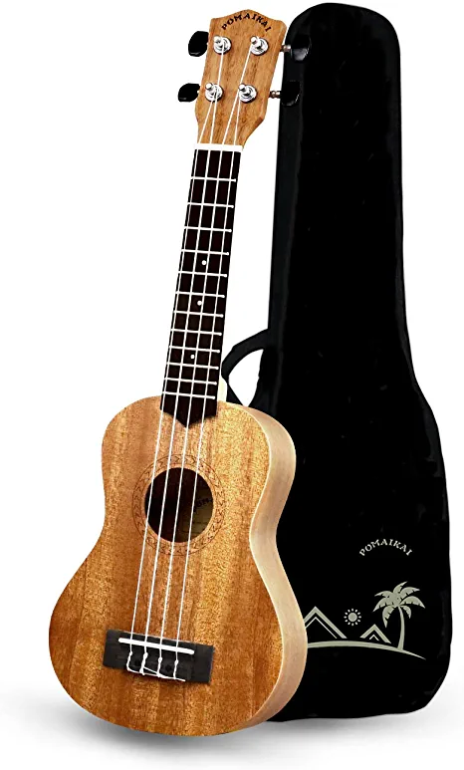 

# Item Description:

# 

# POMAIKAI Soprano Ukulele: Beginner 21 inch Mahogany

# How To Play Ukulele: A Complete Guide for Absolute Beginners - Level 1

Includes: Ukulele, Carrying Case, How to Play Book

Replacement Cost: $50

# 30 inch Snowshoes

# Item #9

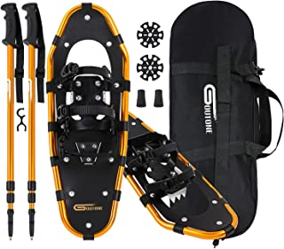

Item Description: Goutone 30 inches light weight snowshoes with adjustable trekking poles and carrying tote bag.

Includes: 1 pair of snowshoes, 2 poles with tip covers, 2 winter baskets, carrying case

Replacement Cost: $95

# 25 inch Snowshoes

# Item #10



Item Description: Goutone 25 inches light weight snowshoes with adjustable trekking poles and carrying tote bag.

Includes: 1 pair of snowshoes, 2 poles with tip covers, 2 winter baskets, carrying case

Replacement Cost: $82

# 21 inch Snowshoes

# Item #11



Item Description: Goutone 21 inches light weight snowshoes with adjustable trekking poles and carrying tote bag.

Includes: 1 pair of snowshoes, 2 poles with tip covers, 2 winter baskets, carrying case

Replacement Cost: $70

# Portable Sound System

# Item #12

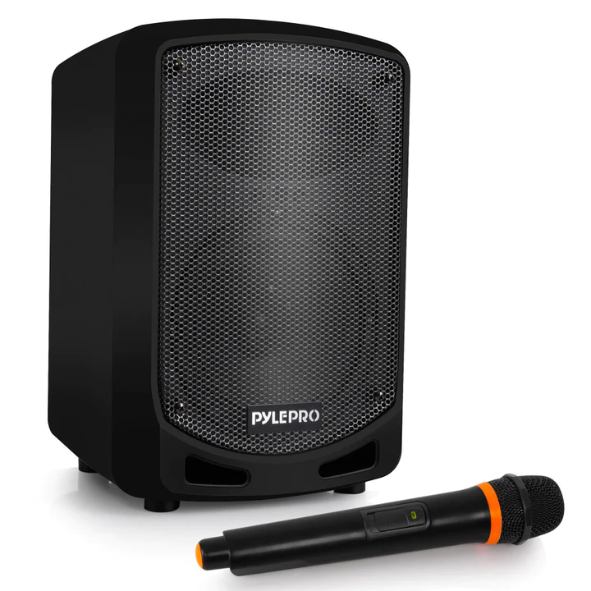

Item Description: Compact and High Powered 600 Watt PA Sound System equipped with 65 inch Subwoofer and 3 inch Treble Speaker for Full Range Stereo Sound Reproduction.

* WIRELESS AUDIO STREAMING: This Indoor / Outdoor Speaker System has a built in Bluetooth with Wireless Range of up to 33 Plus Ft so you can play your favorite song or music from all of your favorite devices like iPhone, Android mobile phone, iPad, Tablet, PC Bluetooth Version 30
* AUDIO CONFIGURATION AND RECORDING: This PA Amplifier Speaker and Mic Set can Record Audio as streamed through the speaker or via the included external microphone which is perfect for rehearsing or singing practice It also has an echo, Bass, and Treble Controls for Dj sounds

Includes: Sound System, Charging adaptor cord, wireless microphone, foam windscreen, User Manual

Replacement Cost: $65

# Large Coffee Maker

# Item #13

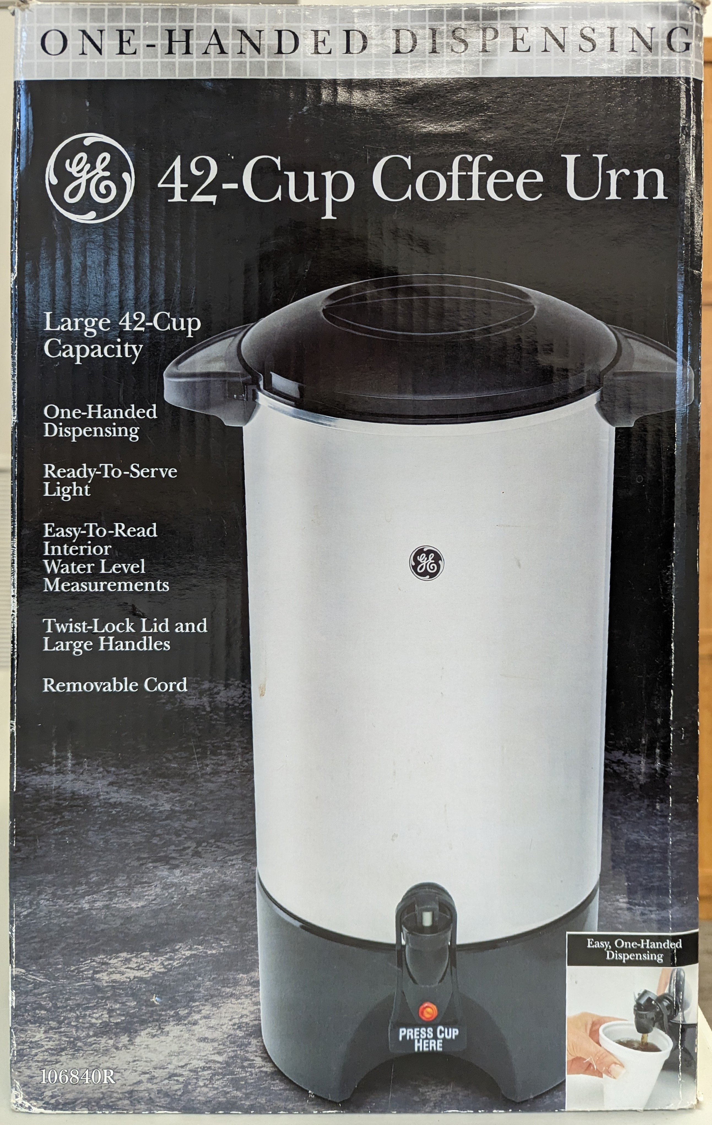

Item Description: 42-Cup Coffee Urn

Includes: Coffee Urn, cover, coffee Basket, stem, power cord, User Manual

Replacement Cost: $60

# Children’s Games

# Item #14

  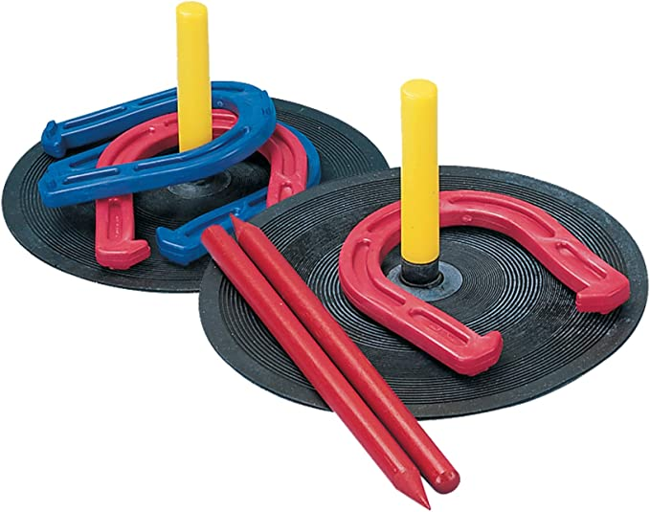

# Item Description: 3 Children’s Game Sets – Bowling, Toss & Catch, Horseshoes

# Includes:

* Melissa & Doug Bowling Friends Preschool Playset - 6 bowling pins, 1 purple bowling ball
* Ball SportsToss and Catch Game Set - 4 Paddles, 4 Balls, storage Bag
* Horseshoe Set – 4 horseshoes, 2 rubber mats with pegs, 2 red plastic dowels

Replacement Cost: $75

# Portable Electric Cooktop

# Item #15

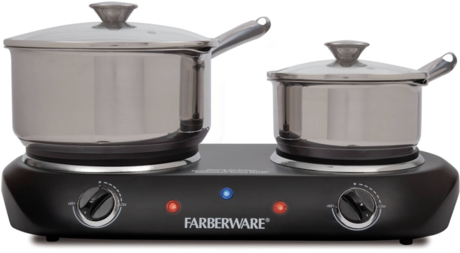

Item Description: The FARBERWARE Double Burner makes it easier to cook in any space. This unit features separate ready lights to indicate when the set temperature has been reached. Back bumpers keep it safely away from the wall.

* Die-cast heating plates
* Separate temperature controls
* Power light
* Separate ready lights indicate when set temperature has been reached
* Back bumpers keep unit safely away from the wall
* Non-skid rubber feet
* 1500W

Includes: Double burner cooktop, User Manual

Replacement Cost: $50

# Projector Screen

# Item #16

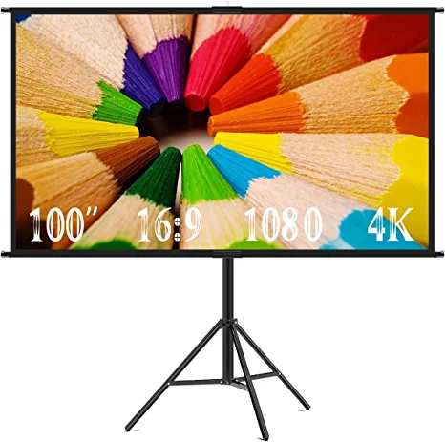

# Item Description: Projector Screen with Stand, 100-inch Indoor/Outdoor Projection Screen, Portable 16:9 4K HD Movie Screen

Includes: 100-inch curtain in protective bag, upper and lower fixators, tripod, 6 crossbars, instruction manual, carrying case

Replacement Cost: $67

# Portable LCD Projector

# Item #17

# 21XtY0g5A8L._AC_.jpg (308×112)

# Item Description: NEC NP-M271X Projector

* Native Resolution: 1024 x 768
* Contrast Ratio: 3,000:1
* Standard Mode Brightness: 2700 lm
* Product Type: LCD Projector

# Includes: Projector, case, insruction manual, software CD, remote, power cord,

# HDMI cord, PC control cord

Replacement Cost: $725

# Mahjong Set

# Item #18

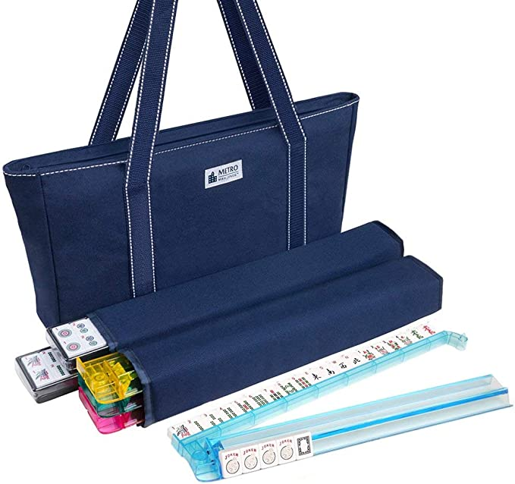

Item Description: Mahjong Set

Includes:

* 166 premium tiles: 36 Dots, 36 Bams, 36 Cracks, 12 Dragons, 16 Winds, 16 Flowers, 10 Jokers, and 4 Blank Spares
* carrying case
* 4 all-in-one pusher and tile rack combo
* 3 large dice
* 100 money chips
* 1 bettor
* Mah Jongg Primer
* Book and Practice Cards

Replacement Cost: $120

# Thermal Leak Detector

# Item #19

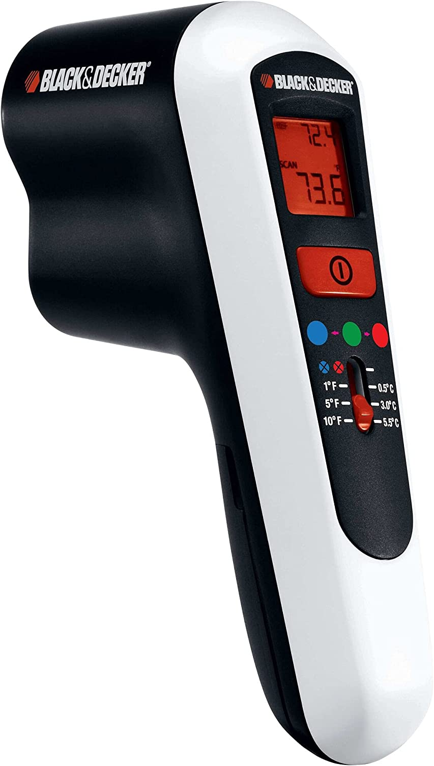

# Item Description: BLACK+DECKER Thermal Leak Detector

Uses infrared sensors to measure surface temperatures. It performs within the ranges as specified for home repair use and should not be used to check the temperature of living beings

Helps homeowners track down power-draining drafts

Includes: Thermal Leak Detector, Instruction Manual

Replacement Cost: $300

# Giant Checkers and Tic Tac Toe Games

# Item #20

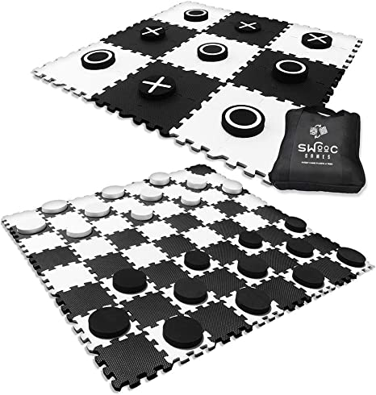

Item Description:

* non-toxic EVA foam tiles that interlock form a huge 4ft x 4ft checkers board & 5in diameter solid foam mega checkers pieces for better grip.
* Rearrange the squares in a matter of seconds to form a 3ft x 3ft tic tac toe board. Flip over the checkers pieces to reveal X's and O's. Make it a tossing game for added challenge and fun.
* Indoor or Outdoor with canvas storage bag.

Includes: 64 foam square interlocking tiles, 5 black X foam circles, 5 black O circles, 2 black foam circles, 12 white foam circles

Replacement Cost: $50

# Connect Four Game (Oversized)

# Item #21

# GUEST_c7452c78-8168-4afd-8a68-3b01002b02cc (325×325)

Item Description: Oversized Connect Four Game

Incudes: game board and stand, 42 discs

Replacement Cost: $60

# Tic Tac Toe (Oversized)

# Item #22

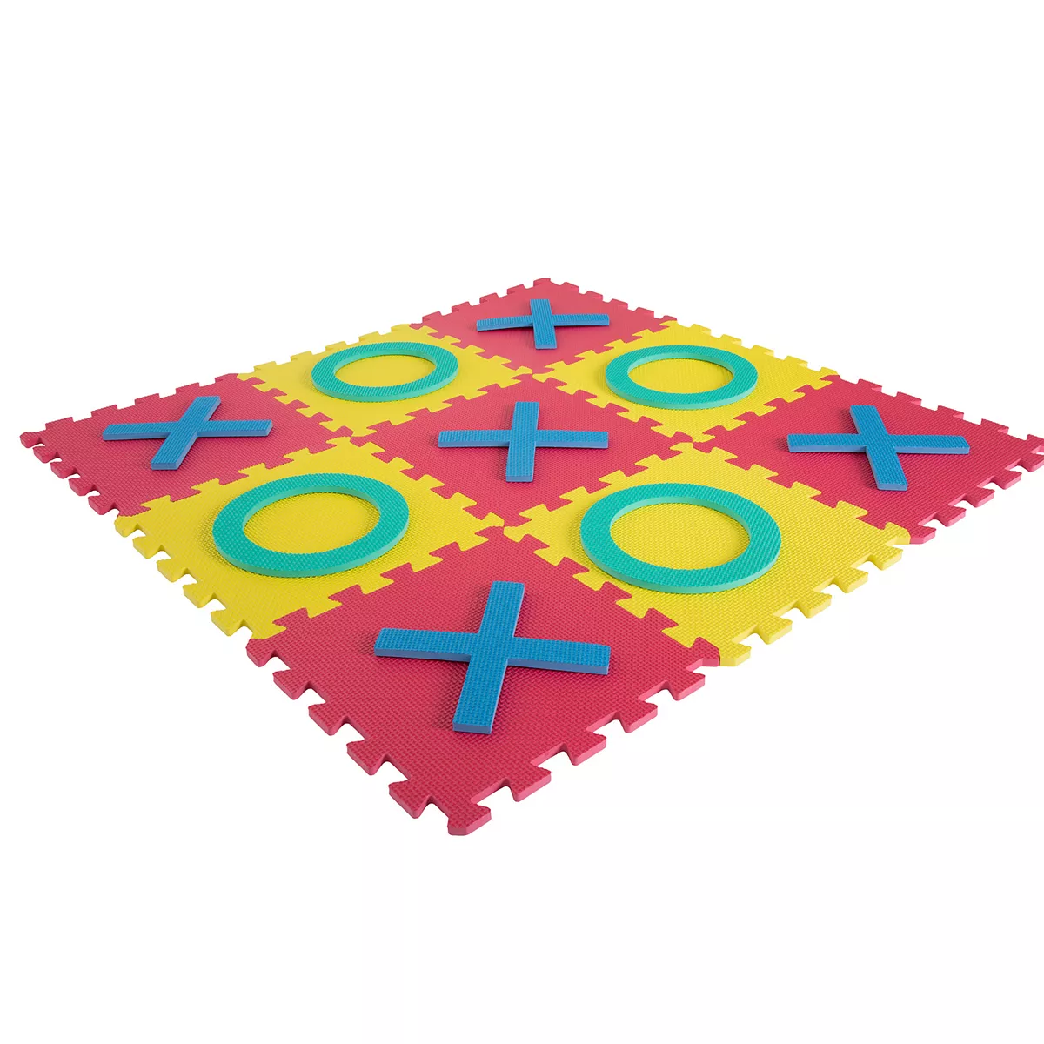

Item Description: Giant Interlocking Foam Square Tic-Tac-Toe Game

* Non-toxic, EVA foam squares provide stable construction, yet a soft surface on which to play
* Easily build a tic-tac-toe game, hopscotch game or create a small surface for other activities
* All pieces can be easily connected & easily cleaned with soap & water

Includes: 9 Interlocking foam tiles, 5 foam X-pieces, 4 foam O-pieces

Replacement Cost: $20

# Record Player

# Item #23

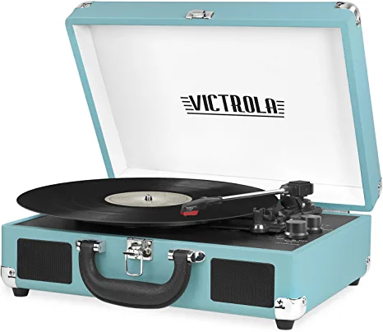

# Item Description: Victrola Vintage 3-Speed Bluetooth Portable Suitcase Record Player

* THREE SPEED BELT-DRIVEN TURNTABLE - This 3-speed (33 1/3, 45, 78 rpm) suitcase record player features UPGRADED PREMIUM SOUND QUALITY and sits on sound isolating feet that prevent vibration.
* TAKE YOUR TUNES ANYWHERE - Housed in a vintage suitcase with an easy carry handle, Victrola's blend of retro and contemporary design give you the ultimate flexibility to listen to music where you want and how you want – a great choice for vinyl lovers
* EXPANDED CONNECTION OPTIONS - Stream smartphone audio through the turntable’s built-in Bluetooth speakers. Easily connect external speakers via the stereo RCA outputs, or use the Line input for non-Bluetooth devices like a CD player. For personal listening, connect your headphones to the headphone jack.
* NO STEREO SYSTEM OR EXTRA EQUIPMENT REQUIRED. Get it up and running in minutes. Retro looks combined with the convenience of modern technology makes this affordable record player ideal for beginners & vintage enthusiasts

Includes: Record Player, instruction Manual, instruction disc, extra stylus, power adaptor

Replacement Cost: $50

# Thermal Imaging Camera

# Item #24

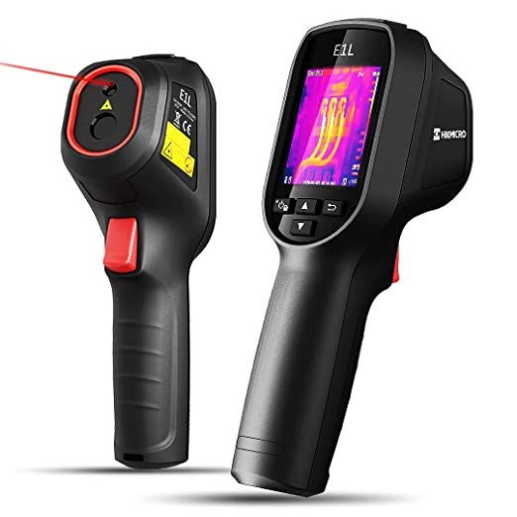

# Item Description: HIKMICRO E1L Compact Thermal Imaging Camera

* HIGH IMAGE QUALITY: Featuring HIKMICRO’s 160 x 120 resolution (19,200 pixels) thermal sensor, the E1L thermal camera delivers outstanding image quality, fast 25Hz frame rates, and a wide temperature range from -20°C to 550°C (-4°F to 1022°F).
* IDEAL THERMAL INSPECTION TOOL: E1L Thermal Imager is perfect for Home Inspections, Missing Insulation, Air Leaks, Water Damage, Facility Maintenance, HVAC Troubleshooting, and professional inspections of electrical and mechanical systems.
* PROFESSIONAL THERMOGRAPHY FEATURES:  Multiple temperature spots (Center, Auto-Hot, Auto-Cold) for fast measurements; multiple color palettes so you can choose the ideal color scale for your job, and storage for >100,000 radiometric images.

Includes: Thermal Imaging Camera with wrist strap, power adapter with 5 international plug options, USB cable

Replacement Cost: $300

# Laser Distance Measure

# Item #25

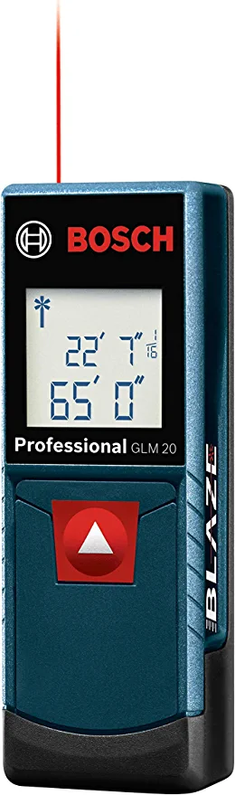

# Item Description: BOSCH GLM20 Blaze 65ft Laser Distance Measure

* Accuracy: Features long range measuring with extreme accuracy and measures distances up to 65 feet to within 1/8 inch. Measures in meters, feet inches, or inches only
* Easy to use: Simple, one button operation press button once to begin measuring. The GLM20 is small enough to fit in any pocket
* Live measuring: Provides default real time measurement that adjusts as you move closer and farther from target, just like a tape measure
* Display: Features a backlit display that allows measurements to be easily read, even in dark areas
* Fits comfortably: Smart and convenient size and shape, easily portable and will rest on any flat surface

Includes: Laser Measure, Operating Manual

Replacement Cost: $40